Linux Assignment

- Task-1 System Monitoring Setup
Install and configure htop or nmon to monitor CPU, memory, and processes.
I have created the install_monitoring_tools.sh to install the htop and nmom
I am using AlmaLinux 10.0
Step -1 Check OS
Run # cat /etc/os-release

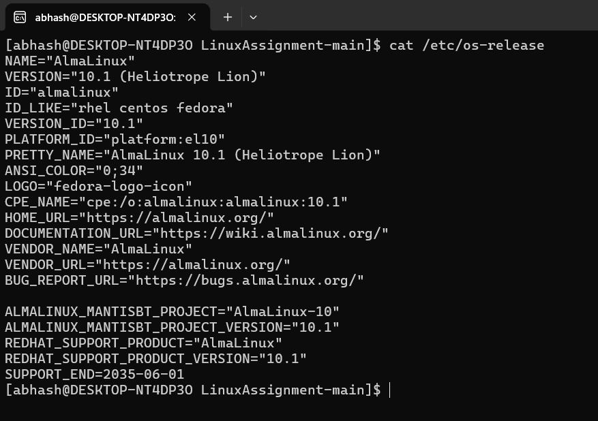

Step -2 Update Local repository
Run # sudo dnf install -y epel-release

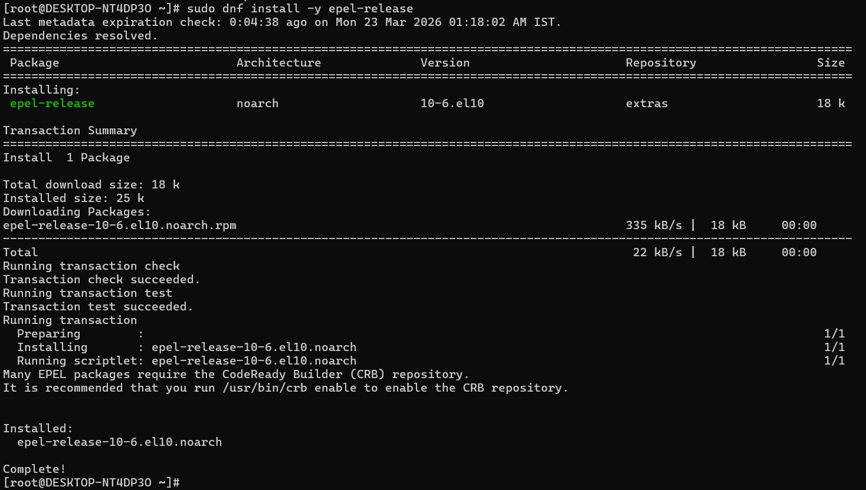

Step – 3 Create script to install htop and nmom
Run # vim install_monitoring_tools.sh
And add the script give below:-
#!/bin/bash
# List of tools
TOOLS=("htop" "nmon")
for tool in "${TOOLS[@]}"
do
if command -v $tool &> /dev/null
then
echo "$tool is already installed."
else
echo "$tool is not installed. Installing..."
sudo dnf install -y $tool
if command -v $tool &> /dev/null
then
echo "$tool installed successfully."
else
echo "Failed to install $tool."
fi
fi
done

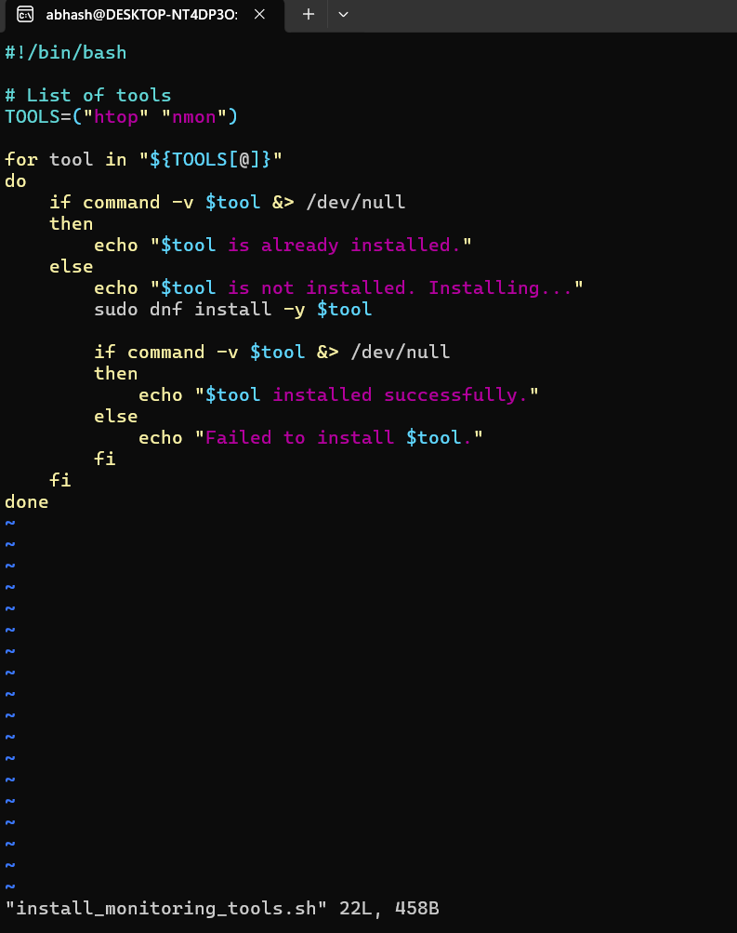

Step – 4 Run scrip via sudo bash
Run # sudo bash install_monitoring_tools.sh

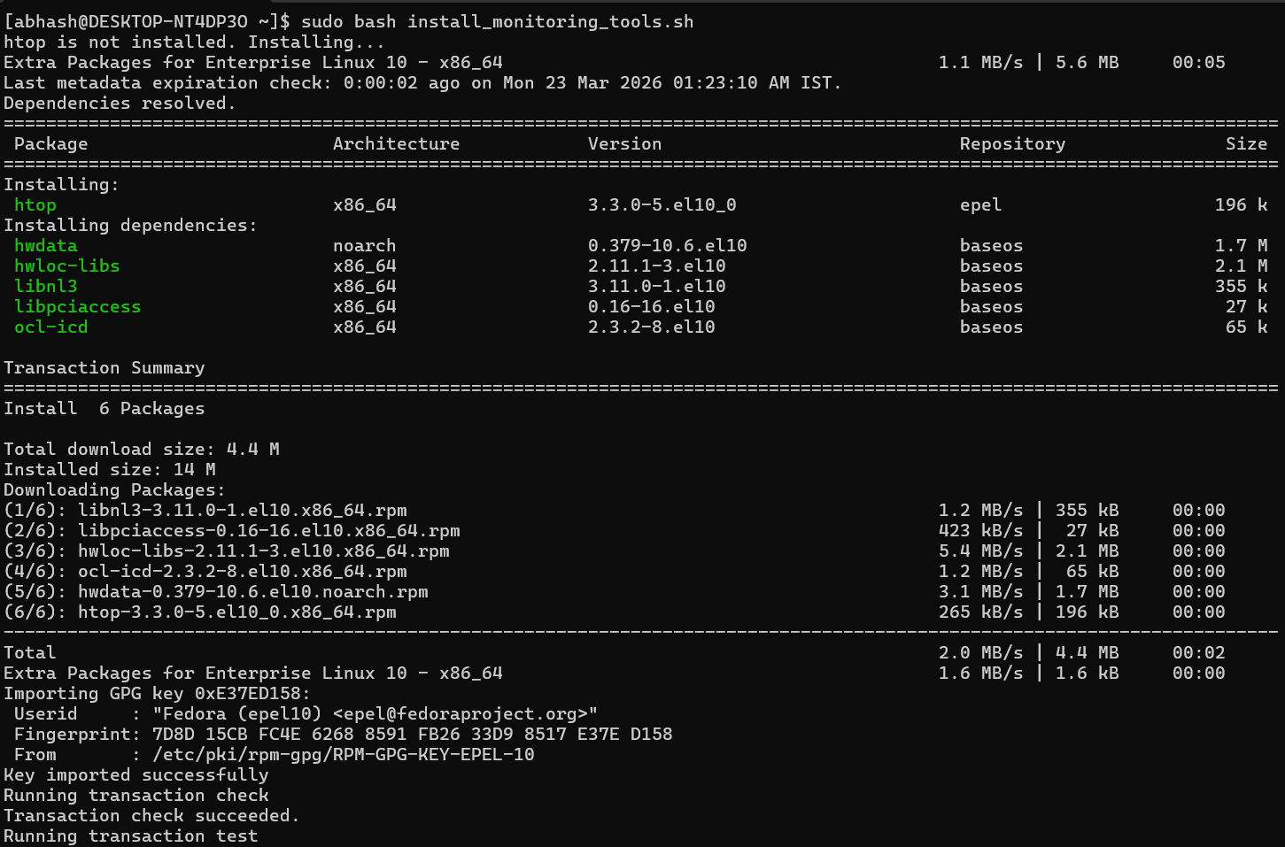
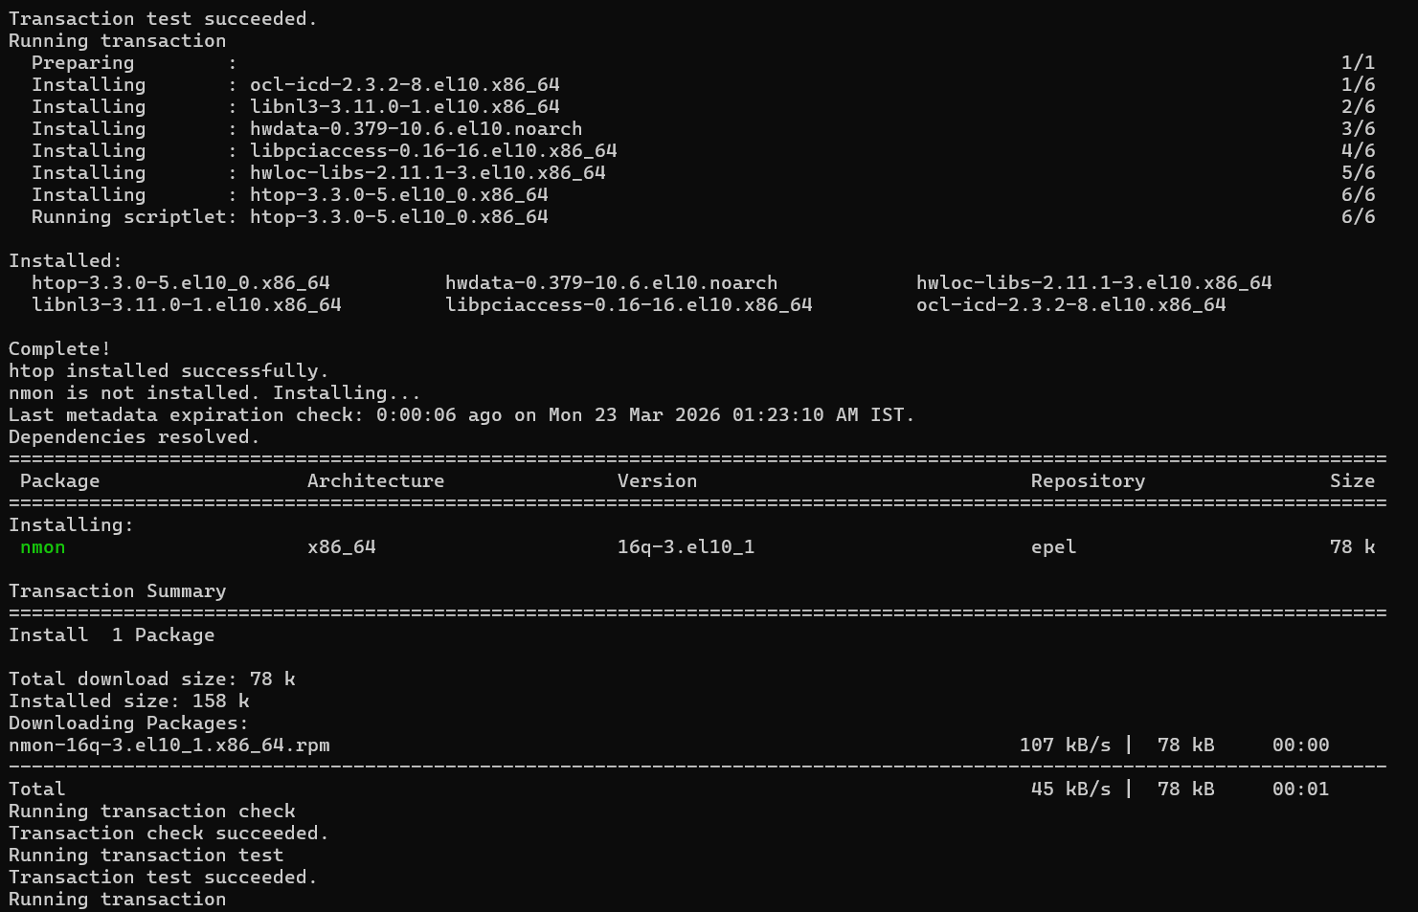

Step -5 check software is installed?
Run # rpm -q htop nmon

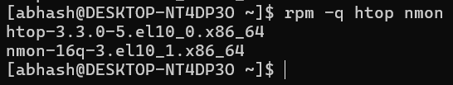

Step – 6 Create monitor.sh to disk usage tracking via df and du and identifying resource-intensive processes.
Run # vim monitor.sh
#!/bin/bash
DATE=$(date)
echo "=========== $DATE ==========" >> $HOME/monitor.log
echo -e "\n\n" >> $HOME/monitor.log
echo "=========== CPU and Memory usage ===========" >> $HOME/monitor.log
top -b -n1 | head -15 >> $HOME/monitor.log
echo -e "\n\n" >> $HOME/monitor.log
echo "=========== Disk usage ===========" >> $HOME/monitor.log
df -h >> $HOME/monitor.log
echo -e "\n\n" >> $HOME/monitor.log
echo "=========== Top Processes ===========" >> $HOME/monitor.log
ps aux --sort=-%cpu | head >> $HOME/monitor.log
echo -e "\n\n" >> $HOME/monitor.log
echo "=============================" >> $HOME/monitor.log

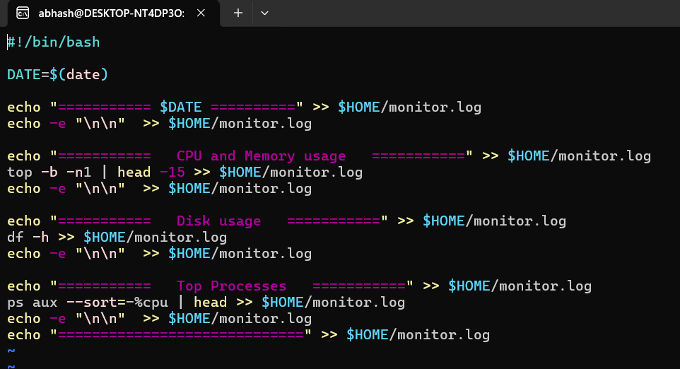

Step -7 Run monitor.sh
Run # monitor.sh
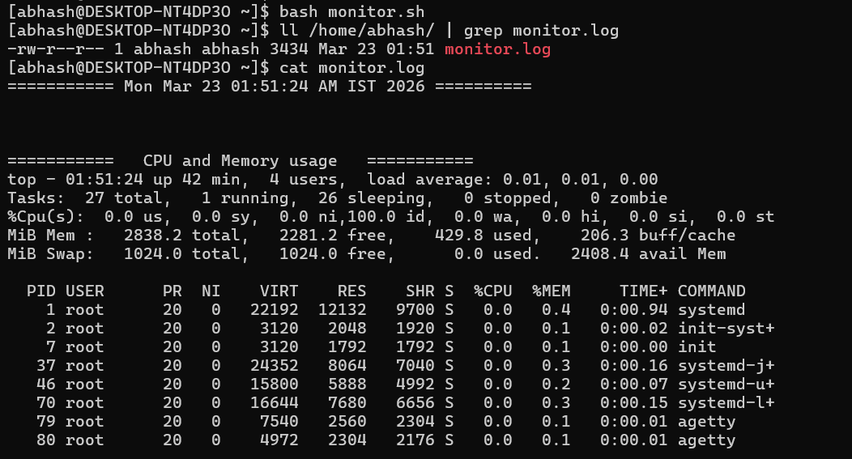
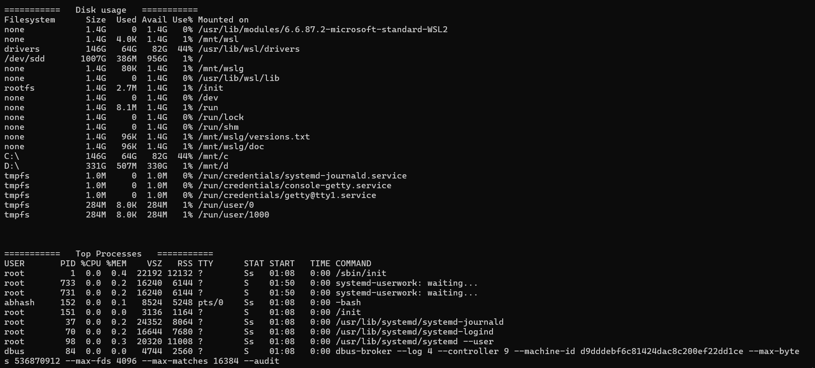

Step – 8 To check the CPU, Memory status run monitor2.sh script
Run # bash monitor2.sh
And choose the option :

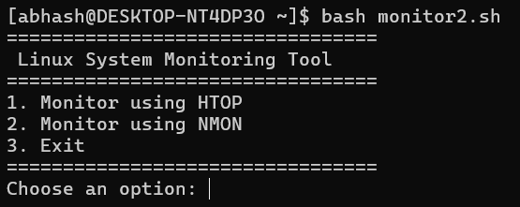

Option 1
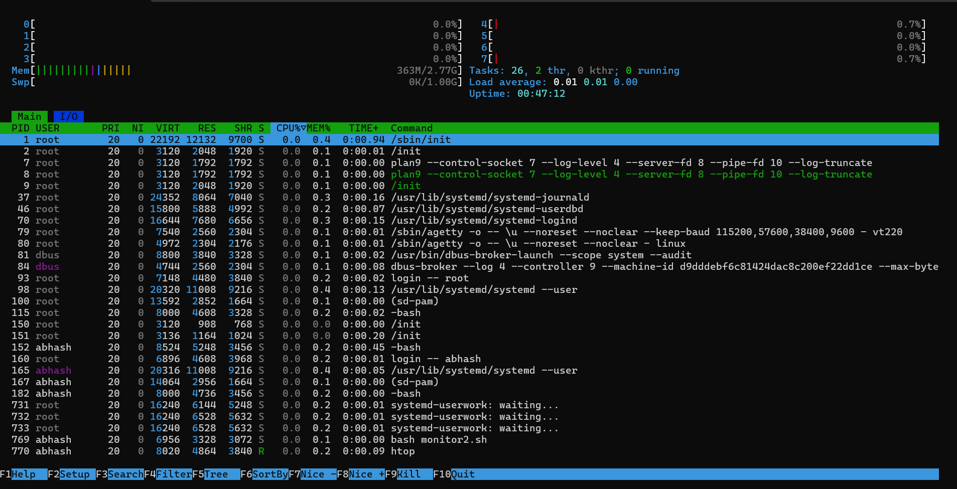

Option 2 – choose multiple options according to check cpu,memory, disk etc
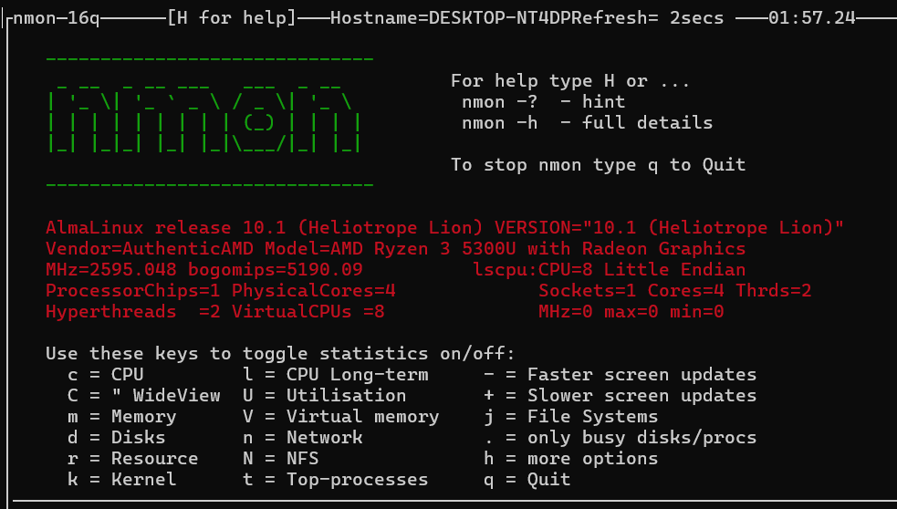
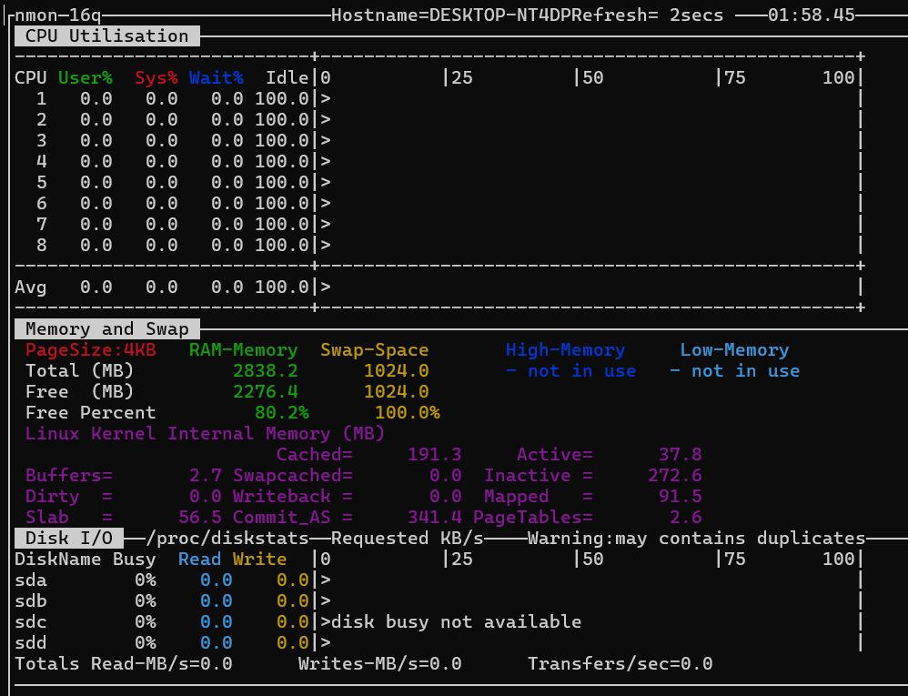
- Task 2 - User Management and Access Control
Step -1 Create user with home dir and setpup workspace only for user specific, set secure password for both users and set password expire policy for
Day’s
Run # vim user_setup.sh and add below script:-

#!/bin/bash

# Script must run as root
if [ "$EUID" -ne 0 ]; then
echo "Please run as root"
exit
fi
echo "Creating users Sarah and Mike..."
# Create users
useradd -m Sarah
useradd -m mike

# Set passwords
echo "Sarah:Secure@123" | chpasswd
echo "mike:Secure@123" | chpasswd

echo "Users created and passwords set."

# Create workspace directories
mkdir -p /home/Sarah/workspace
mkdir -p /home/mike/workspace

# Set ownership
chown Sarah:Sarah /home/Sarah/workspace
chown mike:mike /home/mike/workspace

# Set permissions 700
chmod 700 /home/Sarah/workspace
chmod 700 /home/mike/workspace

echo "Workspace directories created."

# Set password expiry policy
chage -M 30 Sarah
chage -l Sarah

chage -M 30 mike
chage -l mike

echo "Password expiry set to 30 days."
echo "User setup completed successfully."

Step 2 user_setup.sh as sudo
Run # sudo bash user_setup.sh >> user.log

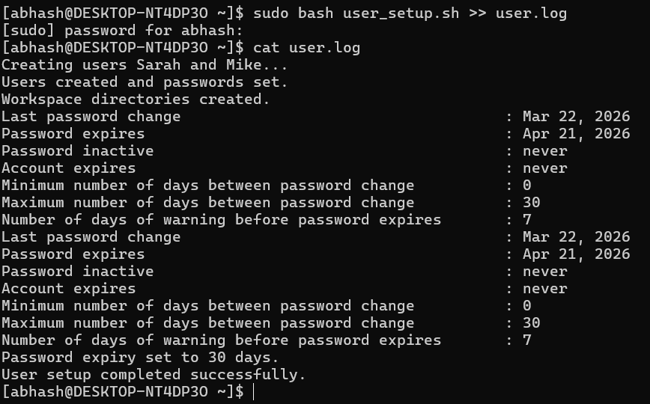
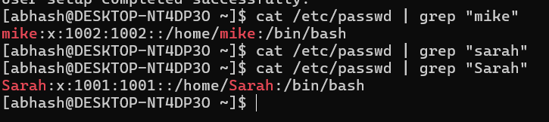

Step 3 Create password_policy.sh for set the password complexity
Run # vim password_policy.sh
#!/bin/bash

CONFIG="/etc/security/pwquality.conf"

echo "Updating password policy..."

set_policy () {
KEY=$1
VALUE=$2

if grep -q "^$KEY" $CONFIG; then
sed -i "s/^$KEY.*/$KEY = $VALUE/" $CONFIG
else
echo "$KEY = $VALUE" >> $CONFIG
fi
}

set_policy minlen 8
set_policy dcredit -1
set_policy ucredit -1
set_policy lcredit -1
set_policy ocredit -1
set_policy retry 3

echo "Password policy updated successfully."

Step 4 – Run password_policy.sh as sudo to set the policy

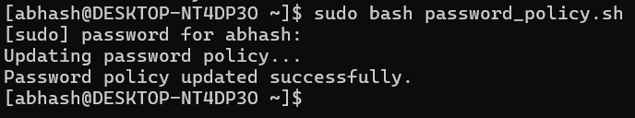

- Task 3 - Backup Configuration for Web Servers
Step 1 - Create script to install Apache and Nginx start services and enable them, create backup repository, create LOG_FILE repository, create archive file into /backup folder and create sub script file for crontab - apache_backup.sh and nginx_backup.sh

#!/bin/bash

mkdir /backups
BACKUP_DIR="/backups"
LOG_FILE="/backups/backup_verification.log"

echo "Checking installed web servers..."

# Check Apache
if rpm -q httpd >/dev/null 2>&1
then
echo "Apache already installed"
APACHE_INSTALLED=true
else
echo "Apache not installed. Installing..."
sudo dnf install -y httpd
sudo systemctl enable httpd
sudo systemctl start httpd
APACHE_INSTALLED=true
fi

# Check Nginx
if rpm -q nginx >/dev/null 2>&1
then
echo "Nginx already installed"
NGINX_INSTALLED=true
else
echo "Nginx not installed. Installing..."
sudo dnf install -y nginx
sudo sed -i -E 's/^(\s*)listen\s+80;/\1listen 8080;/' /etc/nginx/nginx.conf
sudo sed -i -E 's/^(\s*)listen\s+\[::\]:80;/\1listen [::]:8080;/' /etc/nginx/nginx.conf
sudo nginx -t
sudo systemctl enable nginx
sudo systemctl restart nginx

NGINX_INSTALLED=true
fi

echo "Creating backup directory..."
sudo mkdir -p $BACKUP_DIR

# Create Apache Backup Script
cat << 'EOF' | sudo tee /usr/local/bin/apache_backup.sh
#!/bin/bash

DATE=$(date +%F)
BACKUP_FILE="/backups/apache_backup_$DATE.tar.gz"

tar -czf $BACKUP_FILE /etc/httpd /var/www/html

echo "Verifying Apache backup..."
tar -tzf $BACKUP_FILE >> /backups/backup_verification.log
EOF

# Create Nginx Backup Script
cat << 'EOF' | sudo tee /usr/local/bin/nginx_backup.sh
#!/bin/bash

DATE=$(date +%F)
BACKUP_FILE="/backups/nginx_backup_$DATE.tar.gz"
tar -czf $BACKUP_FILE /etc/nginx /usr/share/nginx/html

echo "Verifying Nginx backup..."
tar -tzf $BACKUP_FILE >> /backups/backup_verification.log
EOF

sudo chmod +x /usr/local/bin/apache_backup.sh
sudo chmod +x /usr/local/bin/nginx_backup.sh
echo "Backup scripts created."

echo "Setup completed."
Step 2 Run setup_web_backup.sh scrip as sudo.
Run # sudo setup_web_backup.sh
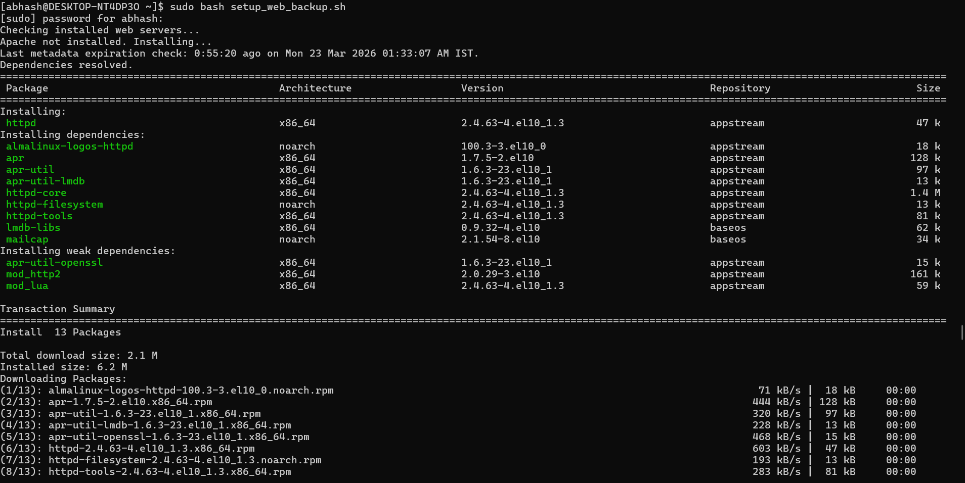
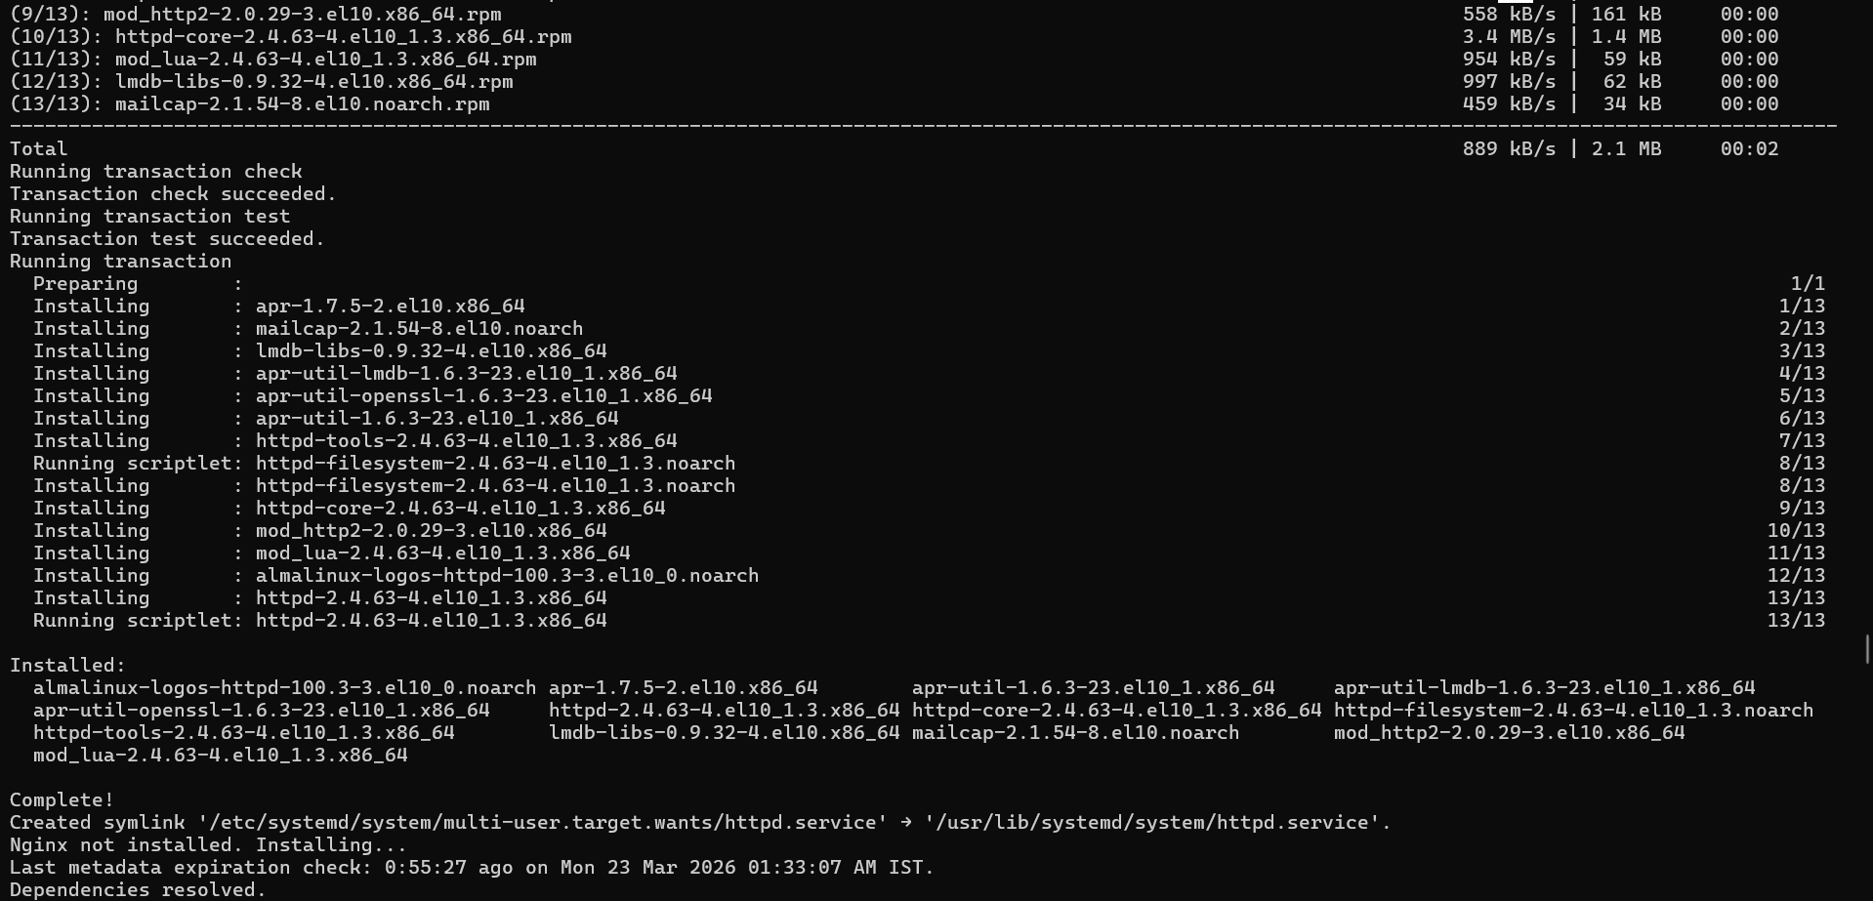
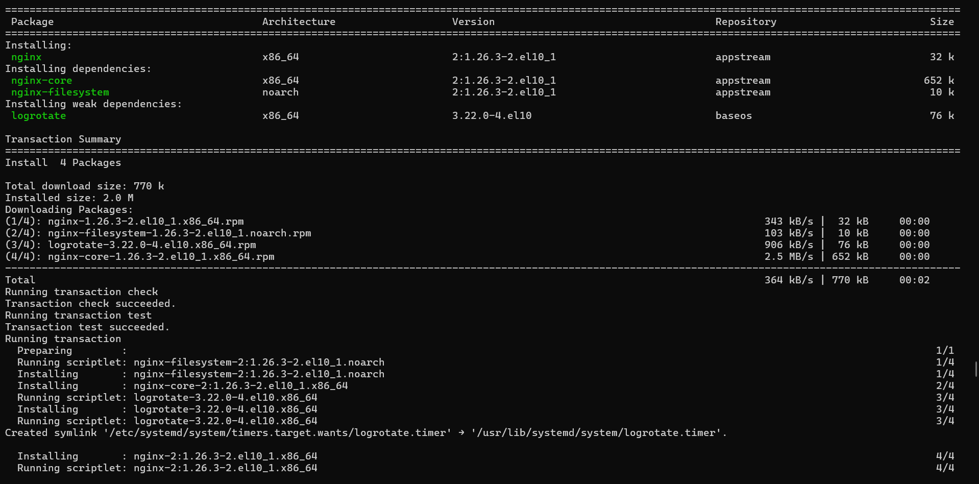
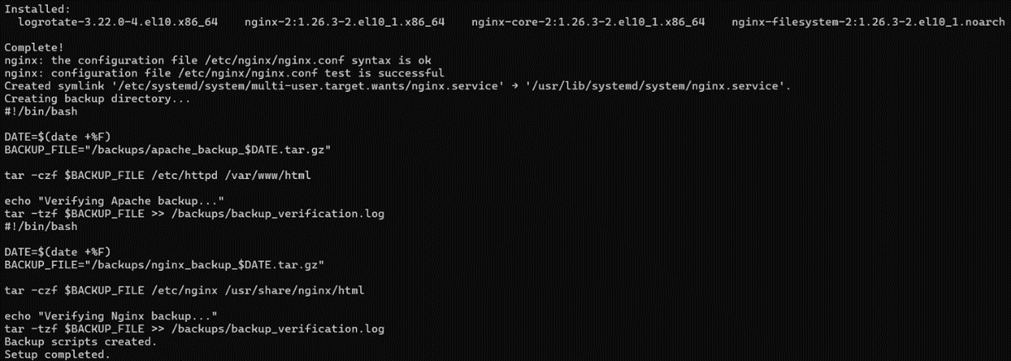

Step 3 check CronTab is installed ?
Run # crontab –e
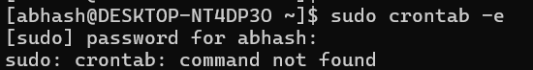

If not installed
Run # sudo dnf install crontab –y
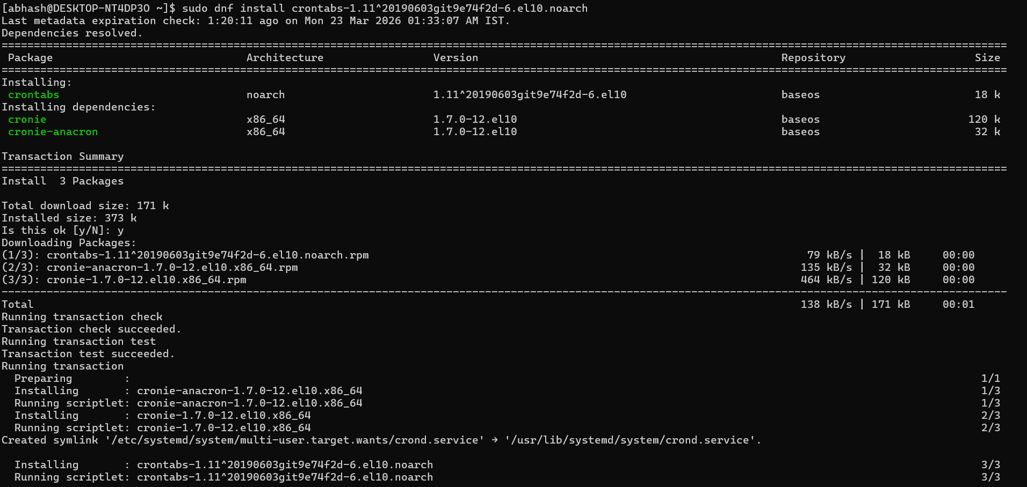

Now edit the crontab file
Run # sudo crontab –e
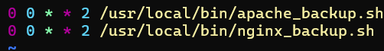

Save and exit
